18. Plot of a VOLLMER Diagram
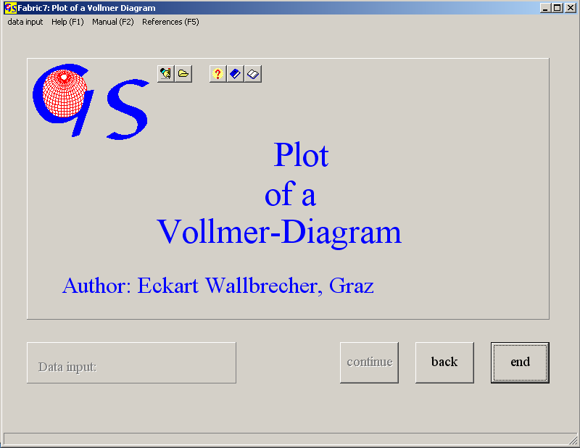
Fig. 1

The program (Fig.1) plots a triangle diagram of the normatized eigenvalues of orientation matrices of orientation data (see programs 8 and 17). The corners of the triangle are 1. even distribution 2. pure clusters 3. pure great circle distributions (VOLLMER, 1990). Input and data list are identical with program 17.
Even distribution is defined as
λ₁ = λ₂ = λ₃ = 1/3.

Therefore, this distribution is represented as 3λ₁ , (3 E1 in the graph). A pure cluster distribution has the eigenvalues

λ₁ = λ₂ = 0; λ₃ = 1.

Therefore this distribution is represented as λ₃ - λ₁ (E3-E1 in the graph). A great circle distribution has the eigenvalues

λ₁ = 0; λ₂ = λ₃ = ½.

Fig. 2 show the graphic form for the data set of program 17. The c-values of the table on the right side are explained in program 17.

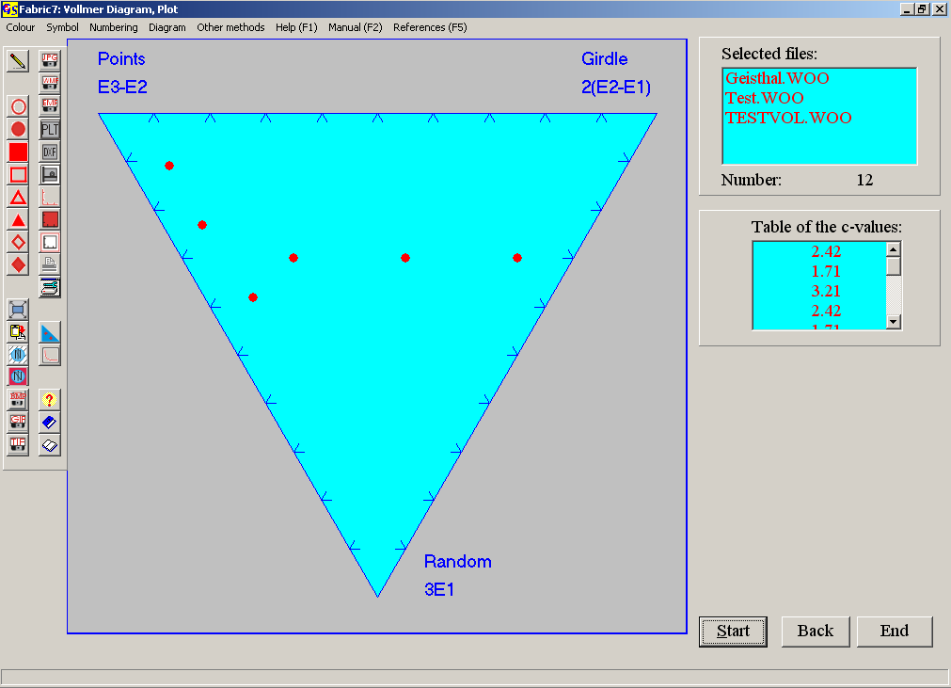Fig. 2

The options of the menu "Diagram" are explained in program 3.
With the menu "Other methods" you jump to the programs 18 or 20 (Woodcock diagram, or test of significance).

